**TITLE** (14 pt; ALL CAPS; BOLD; Times New Roman)

First Author1, Second Author2, Following Authors3 (11 pt; normal; Times New Roman)

e-mail: (contact person) (10 pt; normal; Times New Roman)

1-Affilation of author (1), 2-Affilation of author (2), 3-Affilation of author (3) (10 pt; normal; Times New Roman)

Abstract should be maximum 250 words.

Font: 11 pt; normal; Times New Roman

Paragraph format: before 0, after 6, single spacing.

The Abstract, written entirely in English, should be a condensed version of your oral/poster presentation and include all significant findings of your research. The text should be written in such a way that it interests and excites readers from various fields of expertise about your research's procedures and conclusions. The text should include a brief introduction and motivation of the study, including experimental procedures, main results, and conclusions. It is not necessary to divide the text into sub-sections, except for the References section.

Please do not change the given formatting.

**Keywords:** (up to 5) (11 pt; normal; Times New Roman)

**Introduction**

The papers should be prepared on the standard A4 format (210×297 mm). All the margins are already customized in this template and they should be set at 2.5 cm (top and bottom) and 2 cm (left and right). Header and footer size are 1.5 and 1.25 cm, respectively.

The paper should be 4 to 6 pages long, including tables, figures, and a reference list. The paper must be written in English, using Microsoft Office Word (*.docx; *.doc). Text of the paper should be written in Times New Roman, 12 pt, justified, single line spacing, with no spacing before paragraphs and 6 pt after paragraphs. Please, do not put numbers on the pages.

**Materials and methods**

The manuscript should be organized into the following sections: **Introduction**, **Materials and methods**, **Results and discussion**, **Conclusion**, **Acknowledgement** (optional), and **References**.

Headings, Sub-headings, and *Sub-sub-headings* should be bolded and written in Times New Roman, 12 pt, left-aligned. There should be one line space (12 pt) before the headings and one line space (6 pt) after the headings.

**Results and discussion**

Figures and tables should not exceed the margins of the text of the submitted paper, positioned accordingly to its mentioning in the text. All figures and tables must be cited in consecutive numerical order in the text and referred to in both the text and in the caption as Figure 1, Figure 2, Table 1, Table 2, etc.

Figures and tables should be centered in the text. The data presented in the tables should be written in Times New Roman, 10 pt or smaller. There should be no line space before the table caption and text (besides the paragraph setting) and one line space (12 pt) before the figure and the text. Figures (graphs, photos, schemes etc.) need to be suitable for reproduction and print (minimum 300 dpi).

***Tables*: Tables should have a brief descriptive title. Large tables should be organized vertically to fit within the margins, avoiding borders.**

**Table 1** Caption of the table should be placed above the table (Times New Roman, 11 pt, centered)

|  |  |  |  |
| --- | --- | --- | --- |
| Parameter | Value x, [unit] | Value y, [unit] | Value c, [unit] |
| A | 1 | 2 | 3 |
| B | 4 | 5 | 6 |

*If any, footnotes should be written in Times New Roman, 9 pt, marked with an asterisk or lowercase letters; separated; with a full stop at the end.

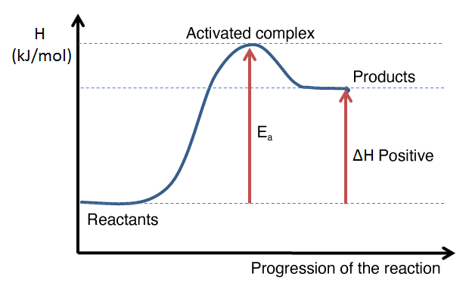

**Figure 1** Caption of the figure should be placed below the figure (Times New Roman, 11 pt, centered)

**Give a reference at the end of the image title - the source from which the image was downloaded, if you didn't create the image yourself. Use the FONT at images as in this text, with the image title always appearing below the image. The letters should be approximately the same dimensions as the letters in the manuscript text (should be legible). The image should be whole and clear (you should not use the drawing tools in Word).**

Please submit math and/or chemical equations as editable text and not as images, placed in the table without any borders, such as done for equation (1). Equations should be left-aligned and numbered consecutively, in rounded brackets (2).

|  |  |
| --- | --- |
| $$x_{1/2}=\frac{-b±\sqrt{b^{2}-4ac}}{2a}$$ | (1) |
| $${Fe}_{2}O_{3\left(s\right)}+{Al}_{\left(l\right)}→{Al}_{2}O_{3\left(s\right)}+{Fe}_{\left(l\right)}$$ | (2) |

**Conclusion**

Dear Authors, your paper(s) should be presented at the Congress orally or in the form of a poster presentation. The area of 0.8 x 1.0 m will be available for your posters. Papers which are not presented on the Congress will not be published in Book of Proceedings.

On behalf of the Organizing Committee of the 6th MME SEE 2025, we wish You a successful Congress and a pleasant stay.

**Acknowledgement**

If any, the text of the Acknowledgement should be written in Times New Roman, 10 pt, normal, justified.

**References**

An updated and complete literature review (at least 50% in the last 5 years) should be conducted to present the state-of-the-art and knowledge gaps in the research, with strong relevance to the topic of the paper. In terms of the types of references to be used, scientific journal articles are preferred. It is critical to ensure that all reference details are correct and complete, as each character is important.

For the references section, authors should follow the LINK: [Chicago style of citation](https://www.chicagomanualofstyle.org/tools_citationguide/citation-guide-1.html).

Order from A-Z:

Agarwal, Priya, Satya Prakash, Gaurav Saini, and Ikhwan Syafiq Mohd Noor. "Recent advances in research from plastic materials to microplastics." *Zastita Materijala* (2024): In-press, <https://doi.org/10.62638/ZasMat1176.>

Jovanović, Aleksandar, Mladen Bugarčić, Aleksandar Marinković, and Miroslav Sokić. "Insights into the application of polyaniline-based composites in environmental engineering." *Metallurgical and Materials Data* 1, no. 1 (2023): 25-31, <https://doi.org/10.30544/MMD1.>

Sokić, Miroslav, Mladen Bugarčić, and Aleksandar Jovanović. "Sphalerite leaching in acid media: a review." Metallurgical and Materials Data 1, no. 2 (2023): 33-43, <https://doi.org/10.30544/MMD8.>

In the manuscript text, the citation style should follow this format for in-text references: (Jovanović et al. 2023; Sokić et al. 2023), or (Agarwal et al. 2024).